GREAT WHITE SHARK MODEL

Made by LEGOs

Victoria Richey and Emily Raper

**

***Warning: This set contains small pieces, which can be a choking hazard***

*For ages 5+ Parent assistance may be required for assembly*

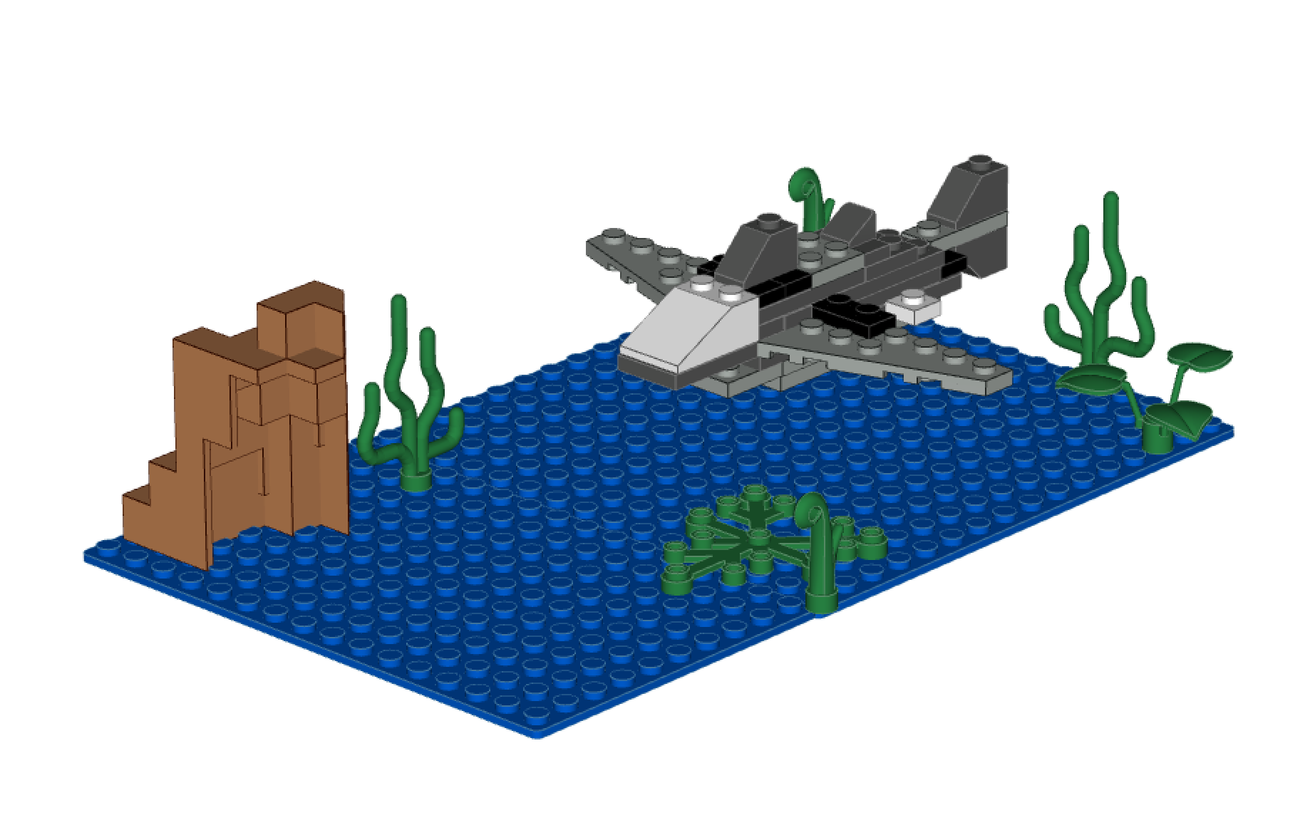 **

*[1]

Do you have an eager explorer that wishes to be closer to our friends under the sea? This Lego Model will let your little scuba diver get close to the famous Great White Shark. Create its ecosystem as well and it’s guaranteed to aide countless hours of imagination and exploration.

This set contains **38 Pieces.**

The pieces that come with this set are listed below:

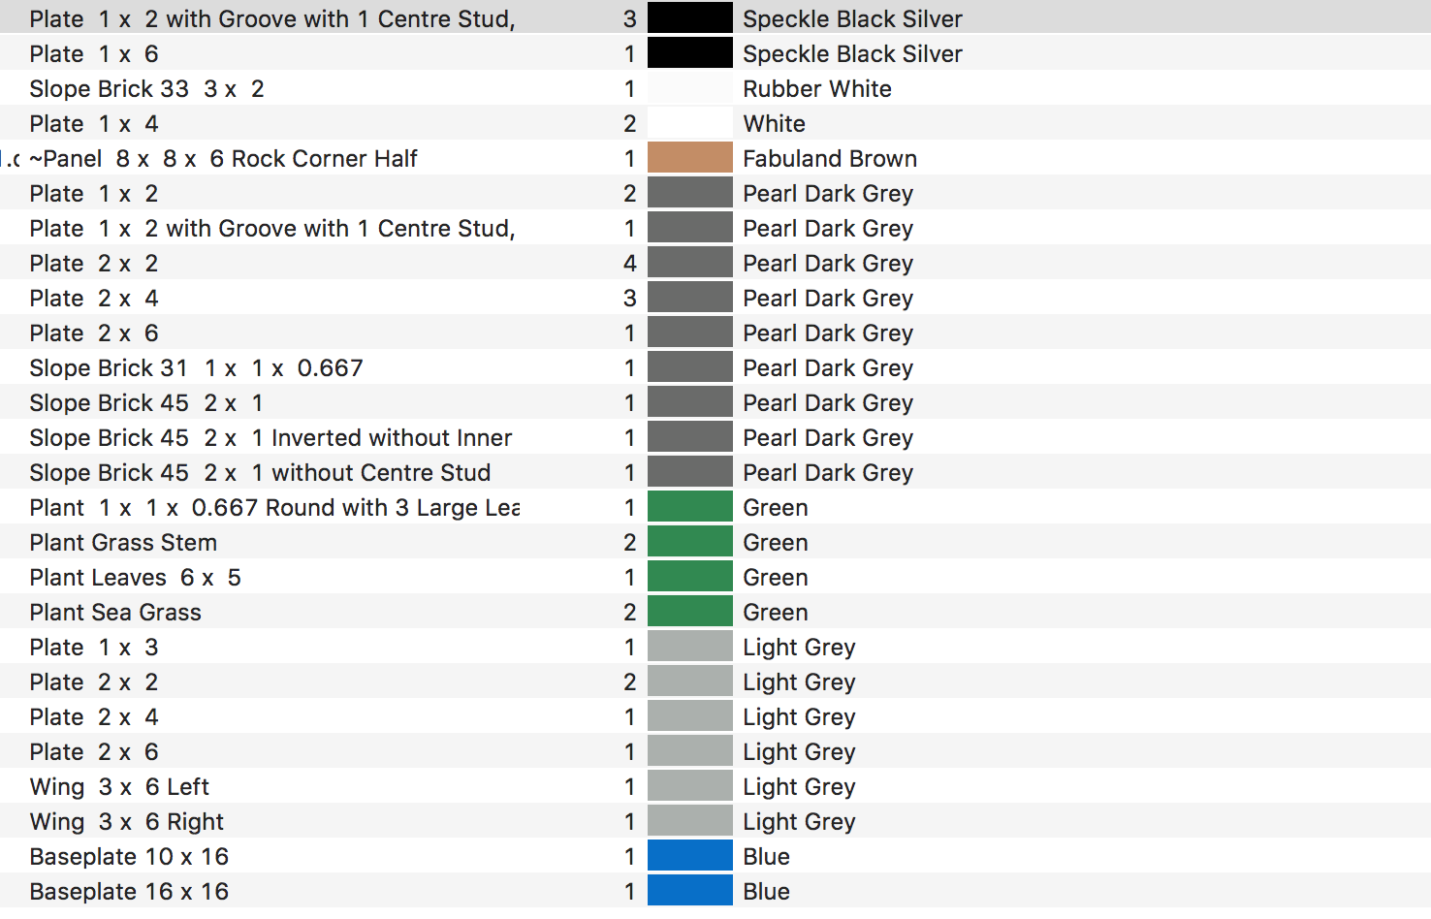

Building the model

**Step 1:**

Connect 2x6 Light Grey Plate on top of 2x4 Light Grey plate

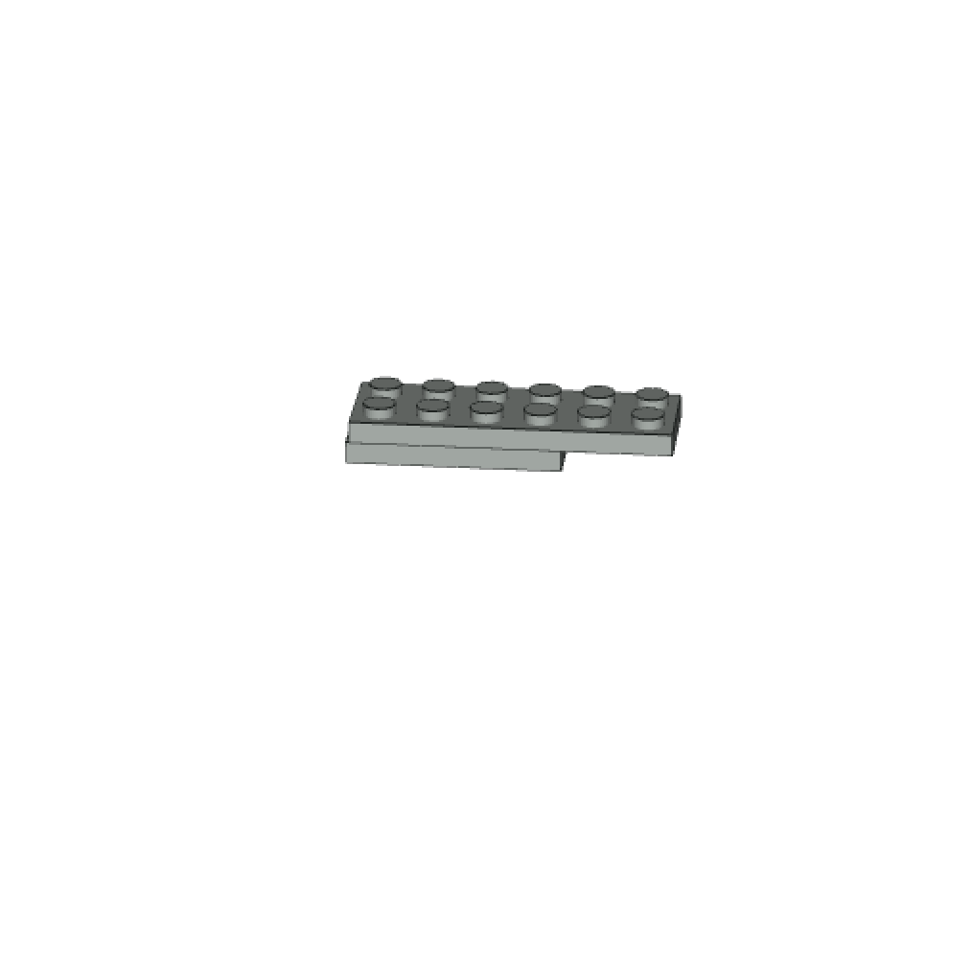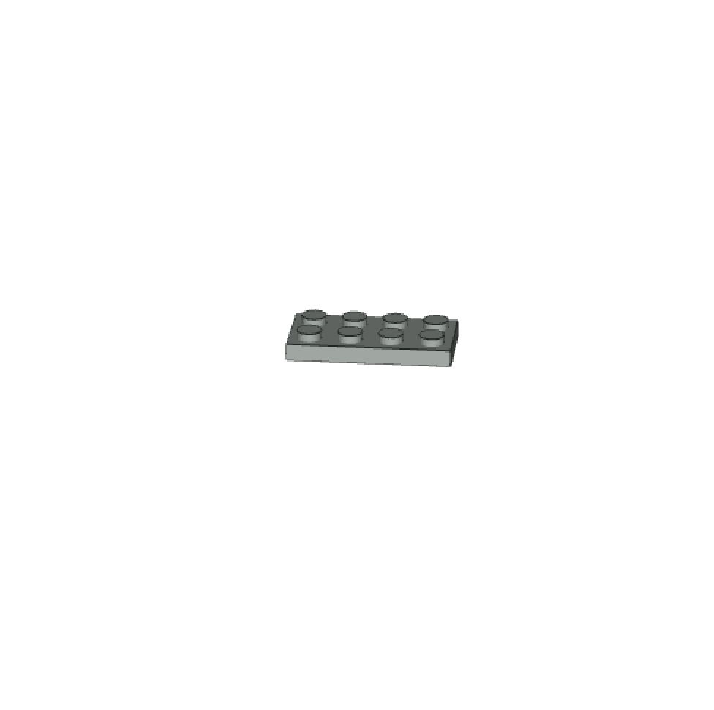

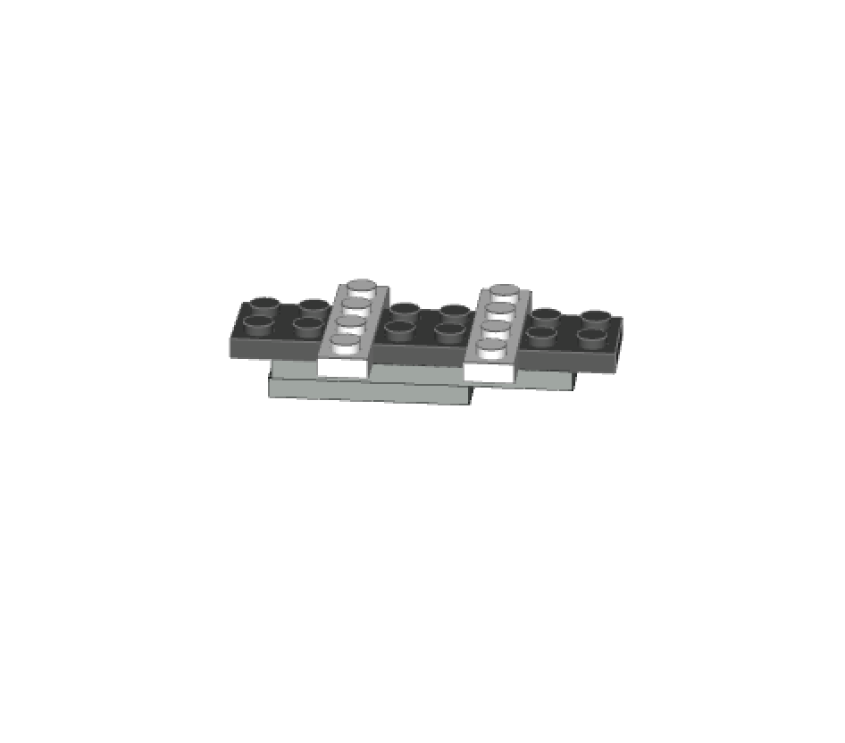**Step 2:**

Above the 2x4 Light Grey plate, attach (3) 2x2 Pearl Dark Grey plates and (2) 1x4 White plates alternatively as show in figure:

**Step 3:**

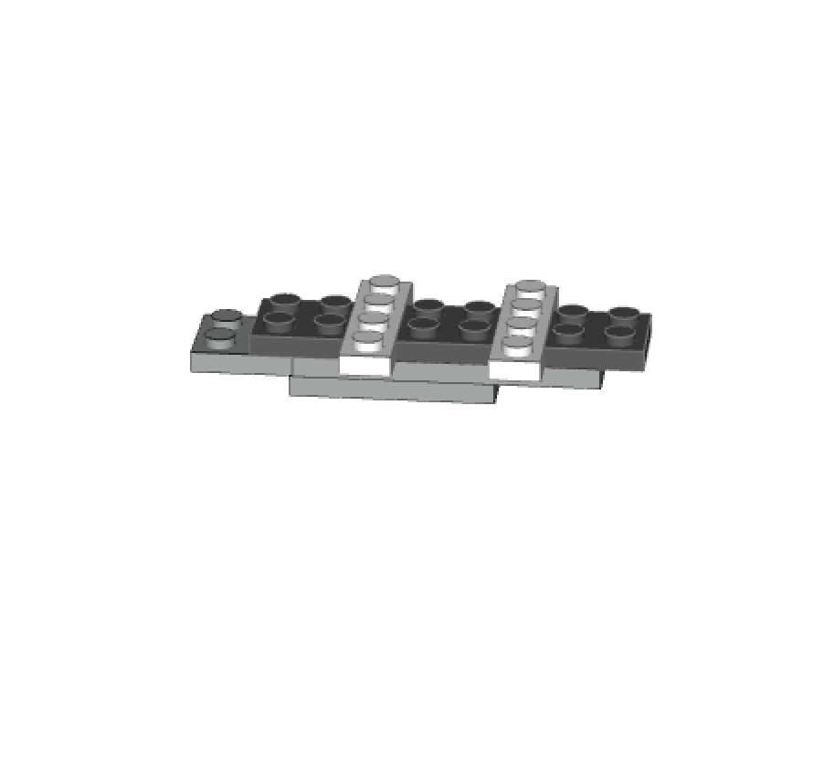Below an additional 2x2 Light Grey plate will be added:

**Step 4: 3 pieces** will be needed

1. 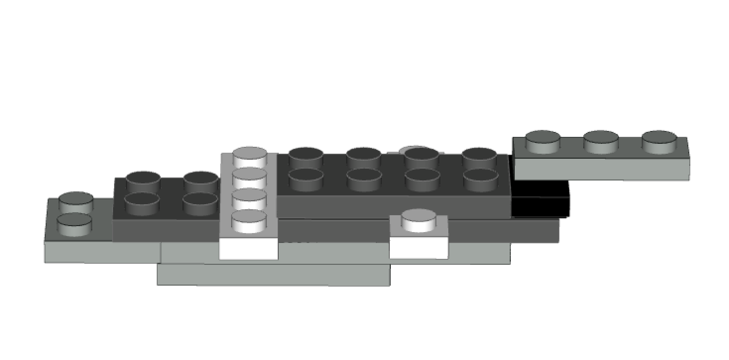1, 2x4 Pearl Dark Grey plate
2. 1, 1x2 with Groove with 1 Centre stud
3. 1, 1x3 Light Grey Plate

Step 4 con’t:

1. 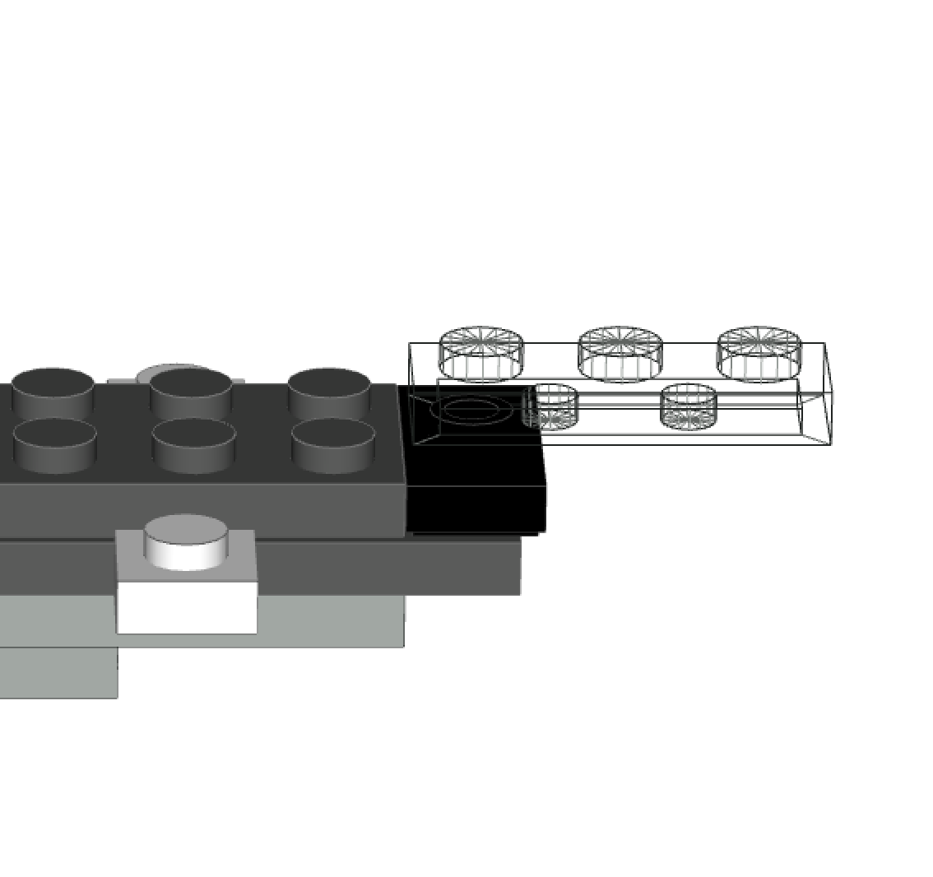Attach the 2x4 Pearl Dark Grey and the 1x2 with Groove with 1 Centre stud on top of the pieces of the previous step. The 1x3 Light Grey Plate will be attached on top of the 1x2 with Groove with 1 Centre stud.

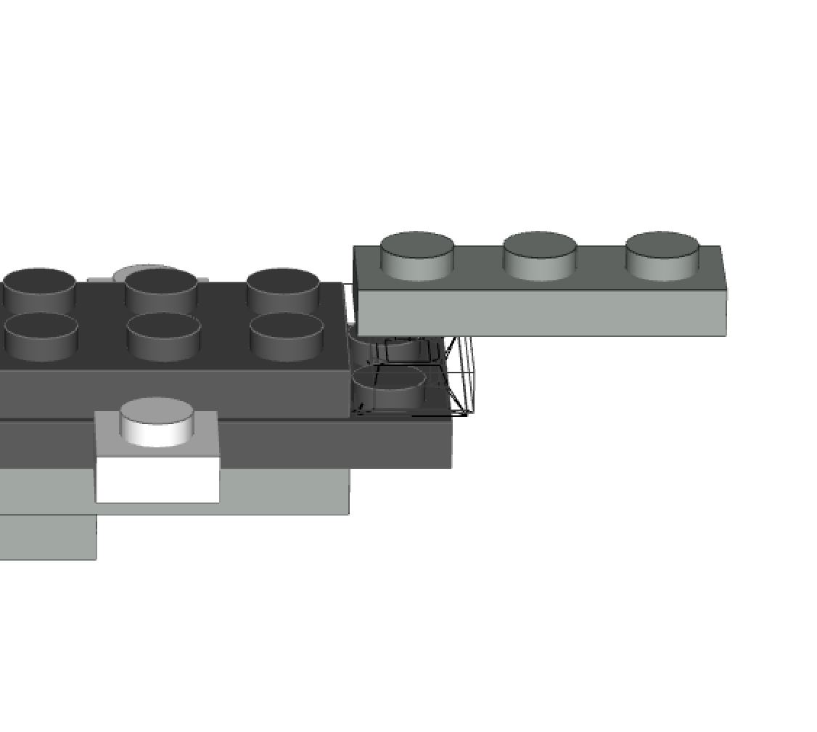

**Step 5: 2 pieces will be needed for this step**

1. 1, 2x4 Pearl Dark Grey plate
2. 1, 2x6 Pearl Dark Grey plate

The 2x4 plate piece will attach above the 2x4 Pearl Dark Grey Plate from step 4.

The 2x6 plate will attach on the visible pieces from step 2. 2x3 pegs should extend out, beginning to form the mouth of the shark.

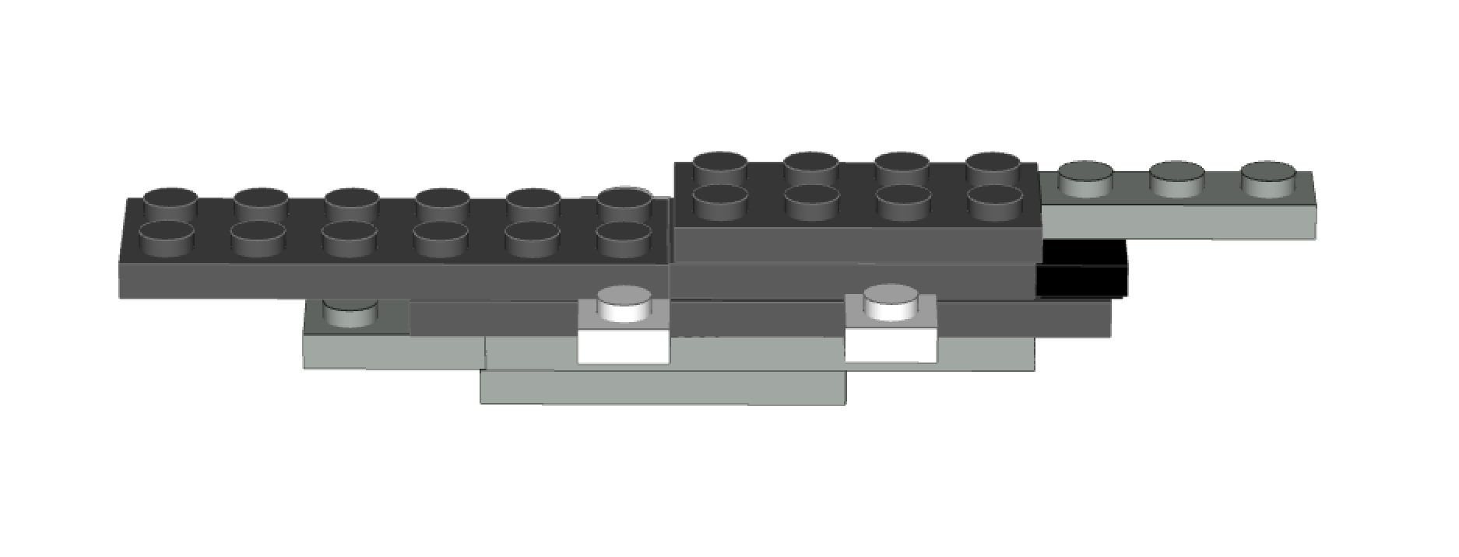

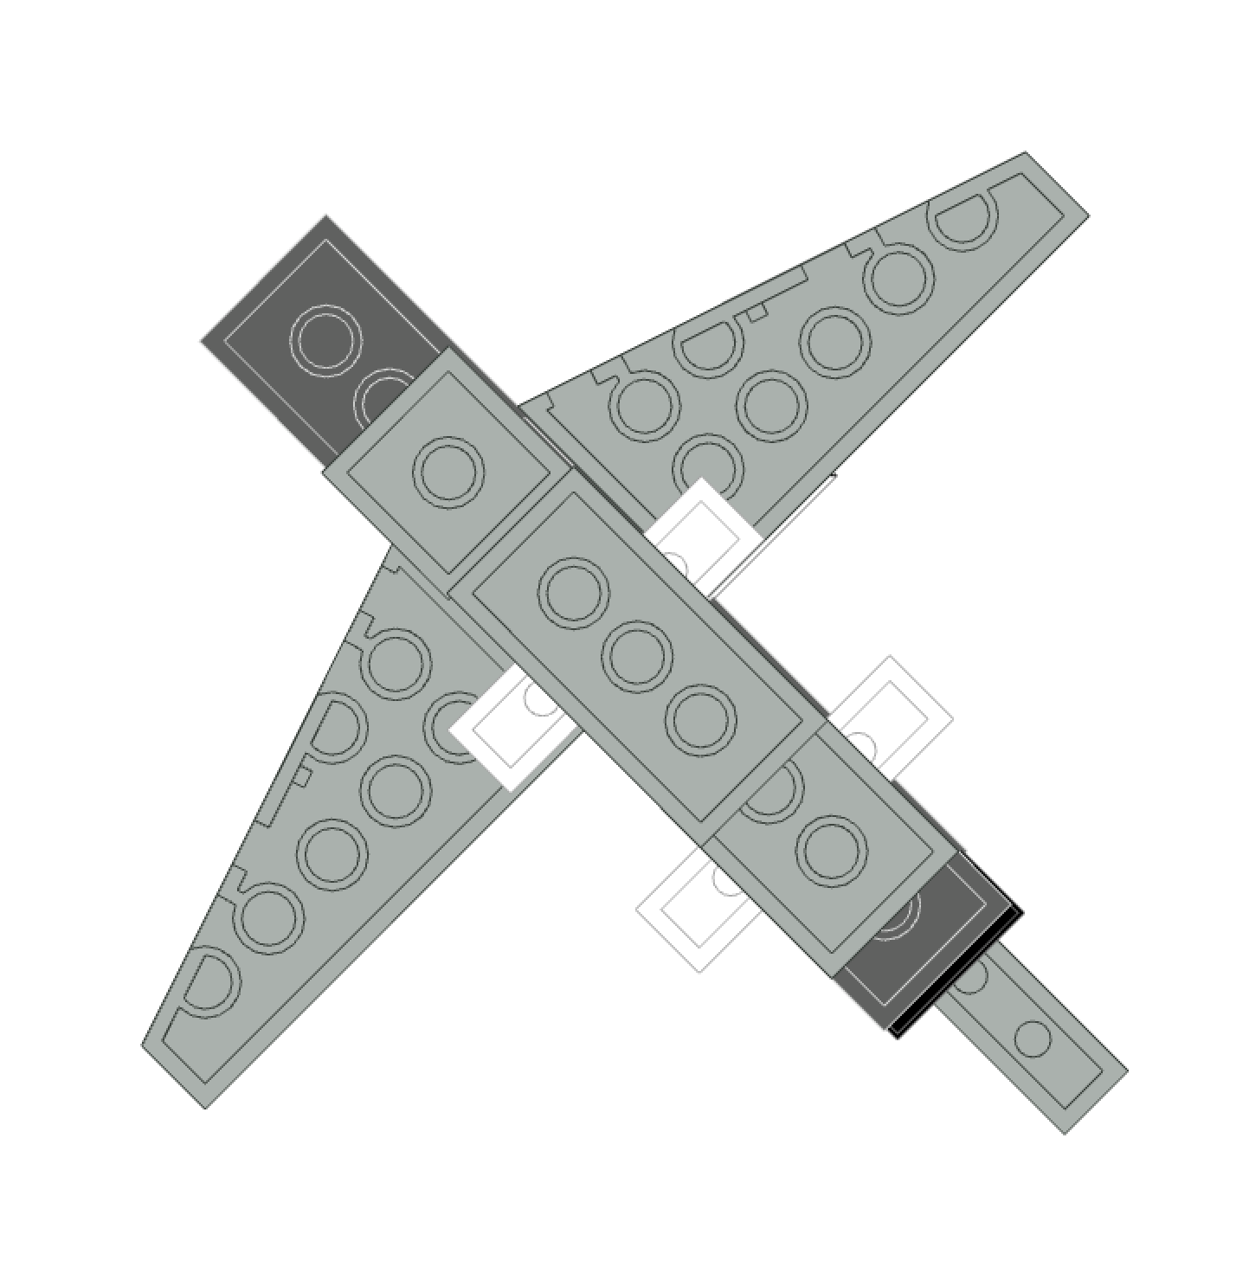This step you will attach the side fins which will be represented by (2) Wing 3x6 Light Grey, left and Right.

**Step 6:**

The slanted parts of the wing piece face the front of the Great White Shark model.

Attach the left and right wing to the 1x3 white plate

Attachment point

Back

Front

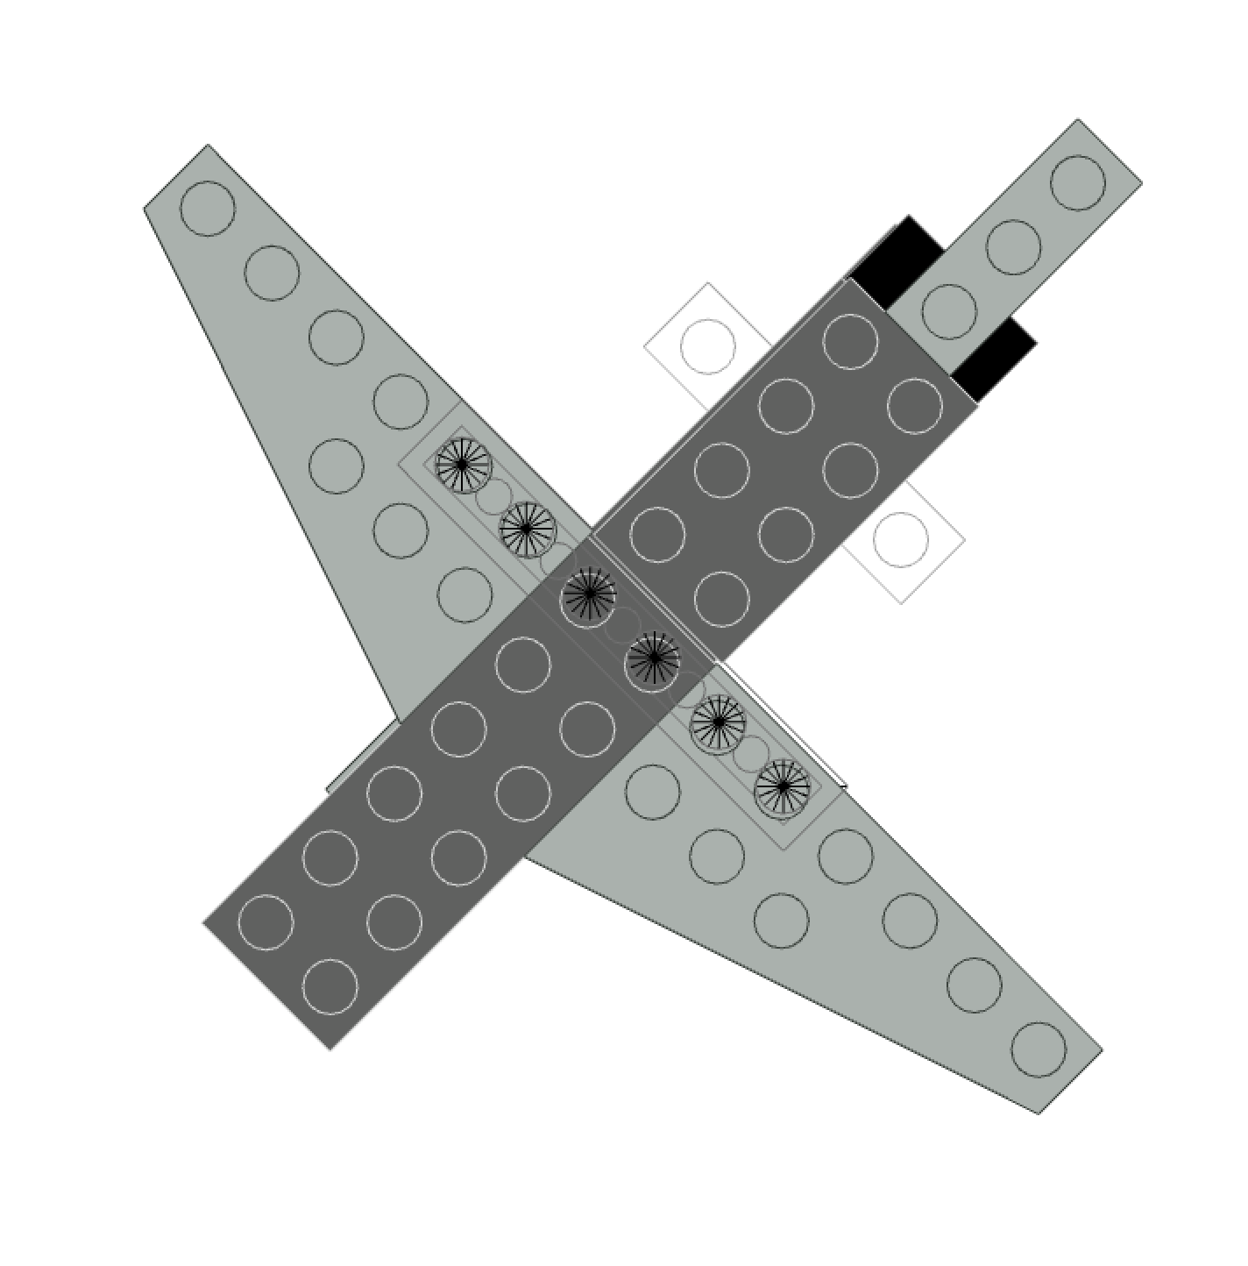

Back

Front

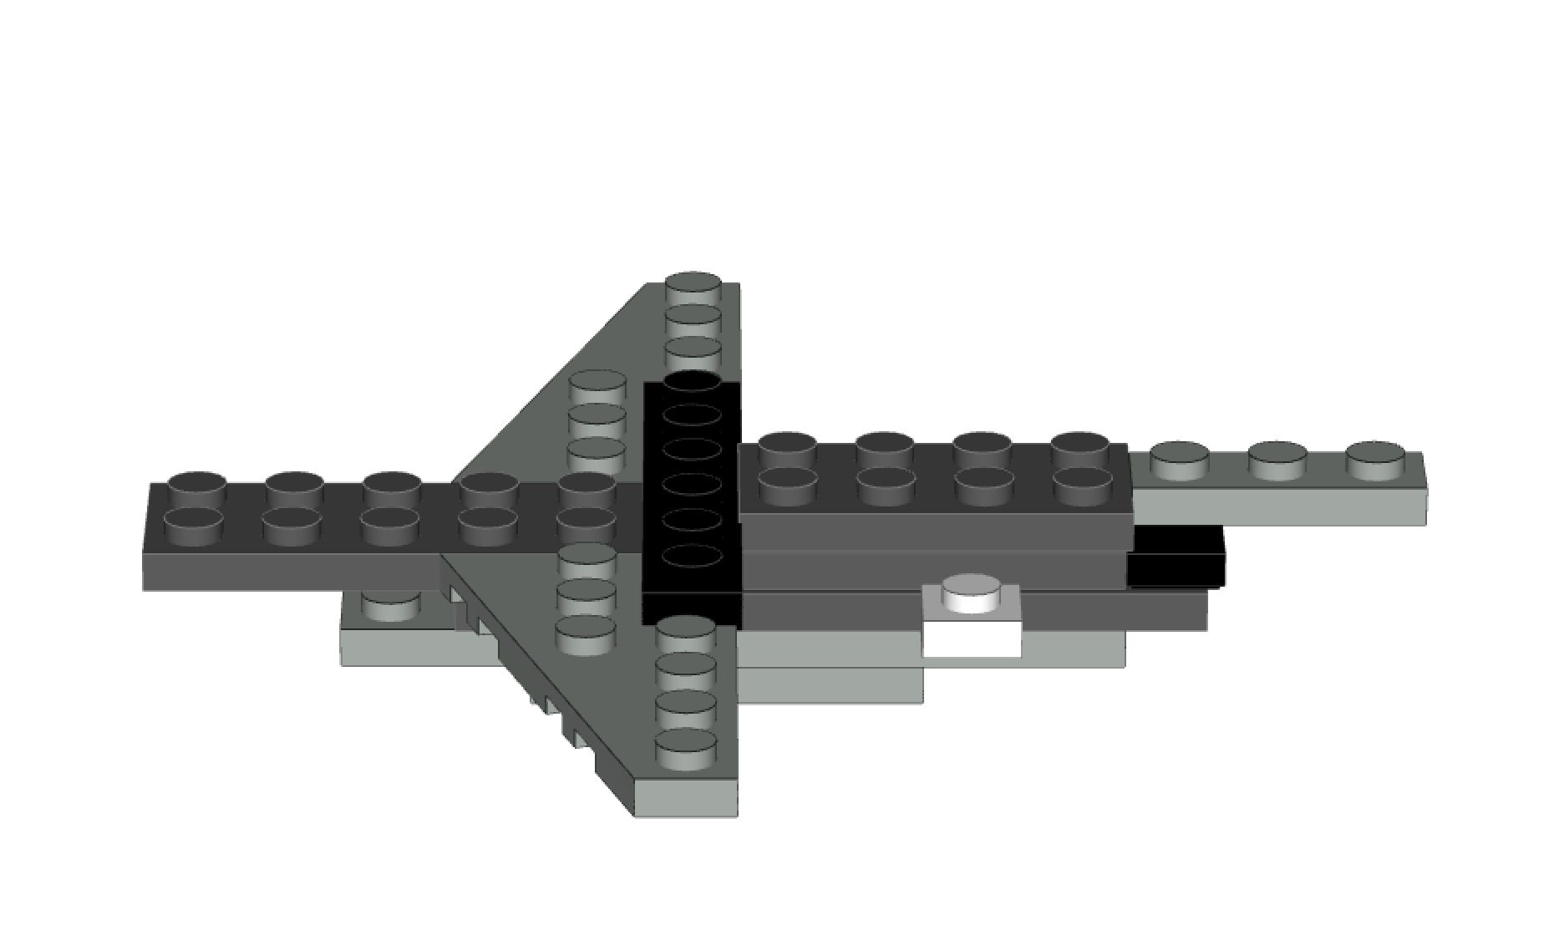**Step 7:**

Behind

Attach a 1x6 Speckle Black Silver plate. Attach **behind** the 1x6 Speckle Black Sliver plate, a 2x4 Pearl Grey plate.

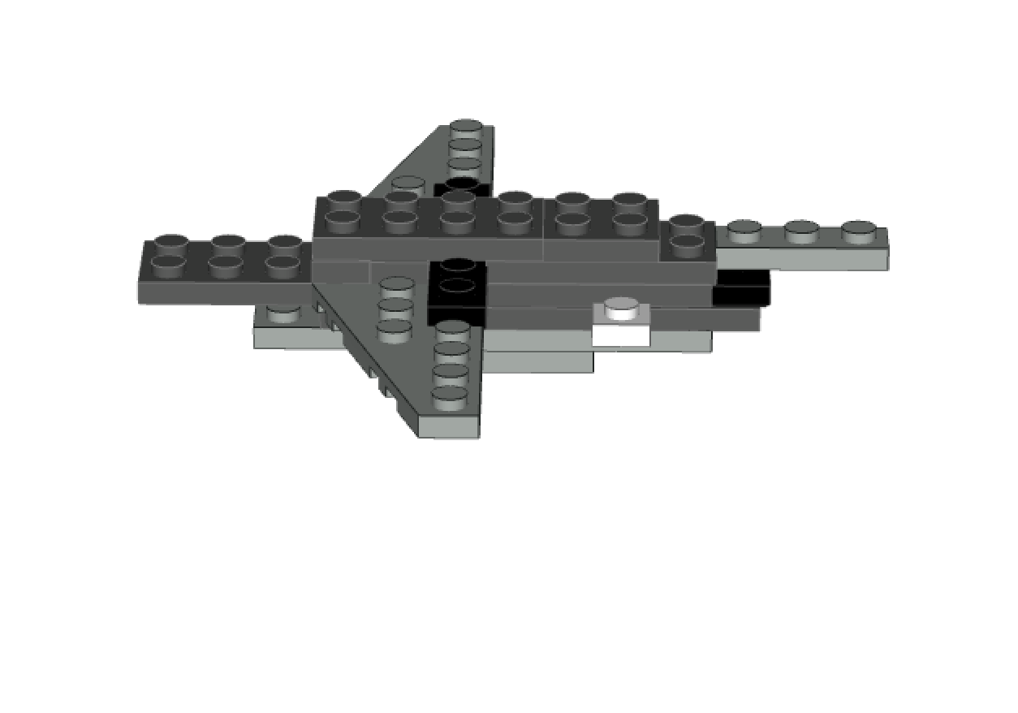**Step 8:**

The next step with have **three parts: a., b., c.**

8.a) Blue box: Attach (2) 1x2 Pearl Grey plates in front of the 1x4 Speckle Black Silver plate (see step 7)

8.b) Orange box: Attach a 2x4 Pearl Grey plate on top of pieces in (8.a)

8.c) Green Box: Attach a 2x2 Pearl Grey plate behind 2x4 Pearl Grey plate.

**Step 9:**

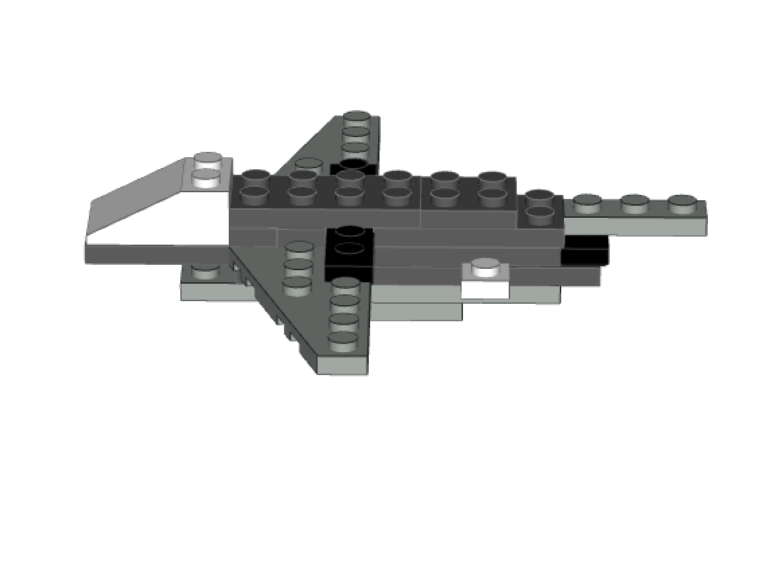Attach the Slope Brick 33 3x2 to the front of the model.

Front

**Step 10:**

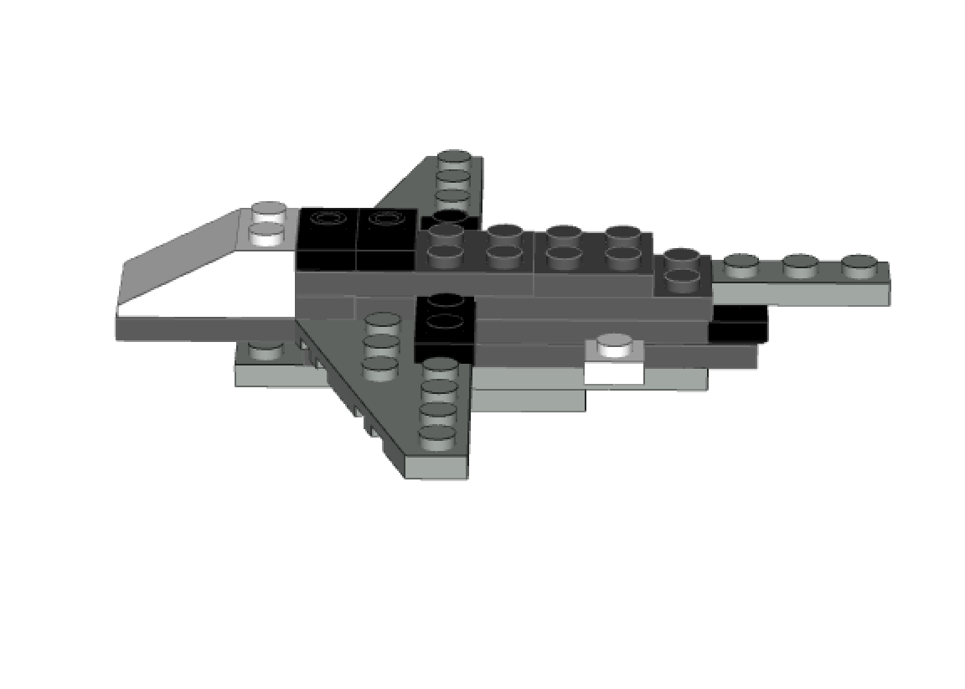Add (2) Speckled Black Silver 1x2 with groove with 1 Centre Stud behind piece from Step 9.

**Step 11:**

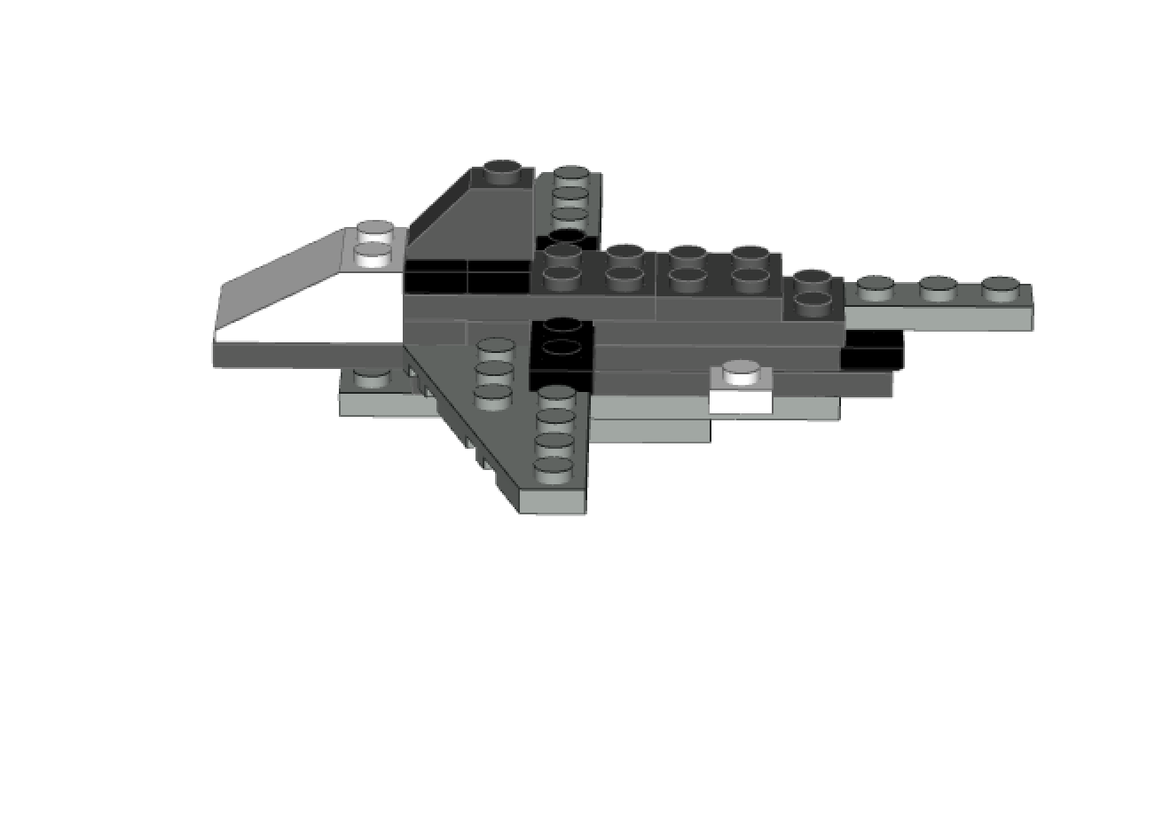

Attach (1) Pearl Dark Grey Slope Brick 45 2x1 on top of pieces from step 10.

**Step 12:**

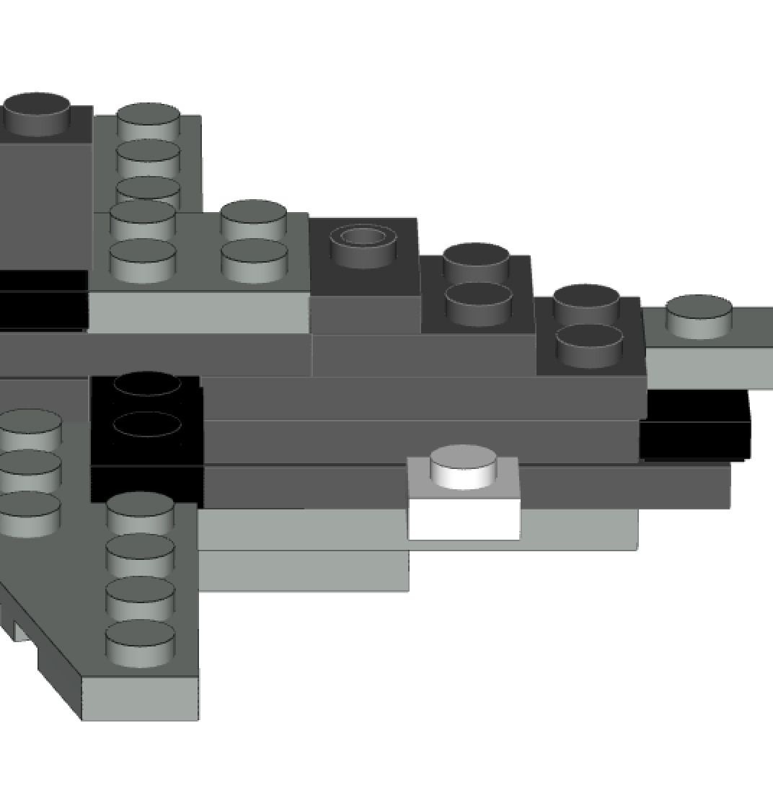

Connect a 2x2 Light Grey plate in front of a 1x2 Pearl Dark Grey with Groove with 1 Centre Stud.

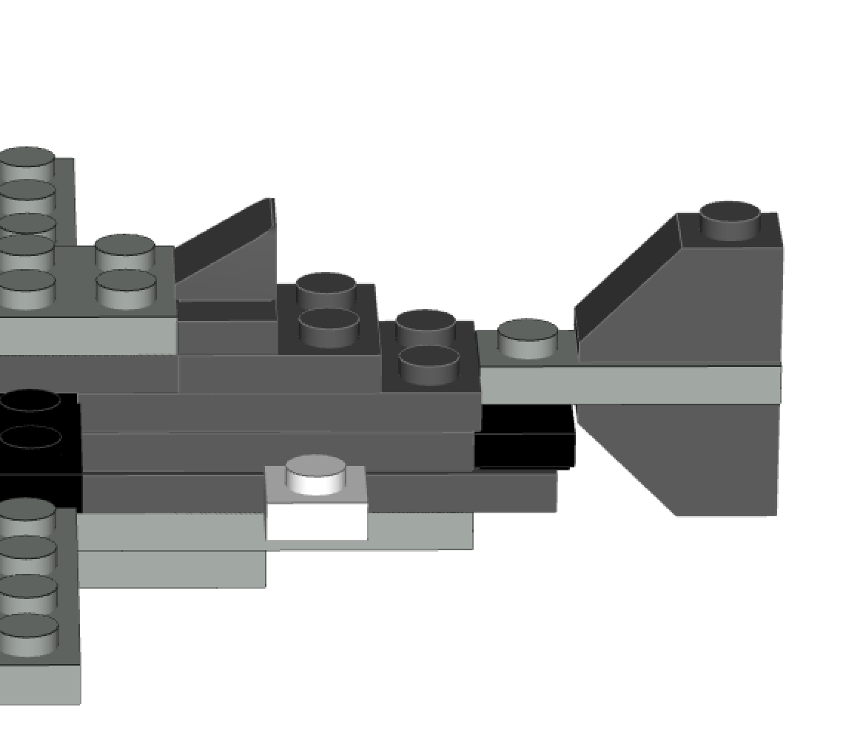**Step 13:**

Now it’s time to assemble the fins.

Connect (1) Pearl Dark Grey Slope Brick 1x1x0.667 to the 1x2 Pearl Dark Grey with Groove with 1 Centre Stud.

**Step 14:**

Connect a Pearl Dark Grey Slope Brick 2x1 and Pearl Dark Grey

Slope Brick 2x1 Inverted without inner to the 1x3 Light Grey

Plate. The Pearl Dark Grey Slope Brick 2x1 will connect on top.

Pearl Dark Grey Slope Brick 2x1 Inverted without inner will

connect to the bottom.

**Step 15:**

The outcome will create a Great White Shark Model

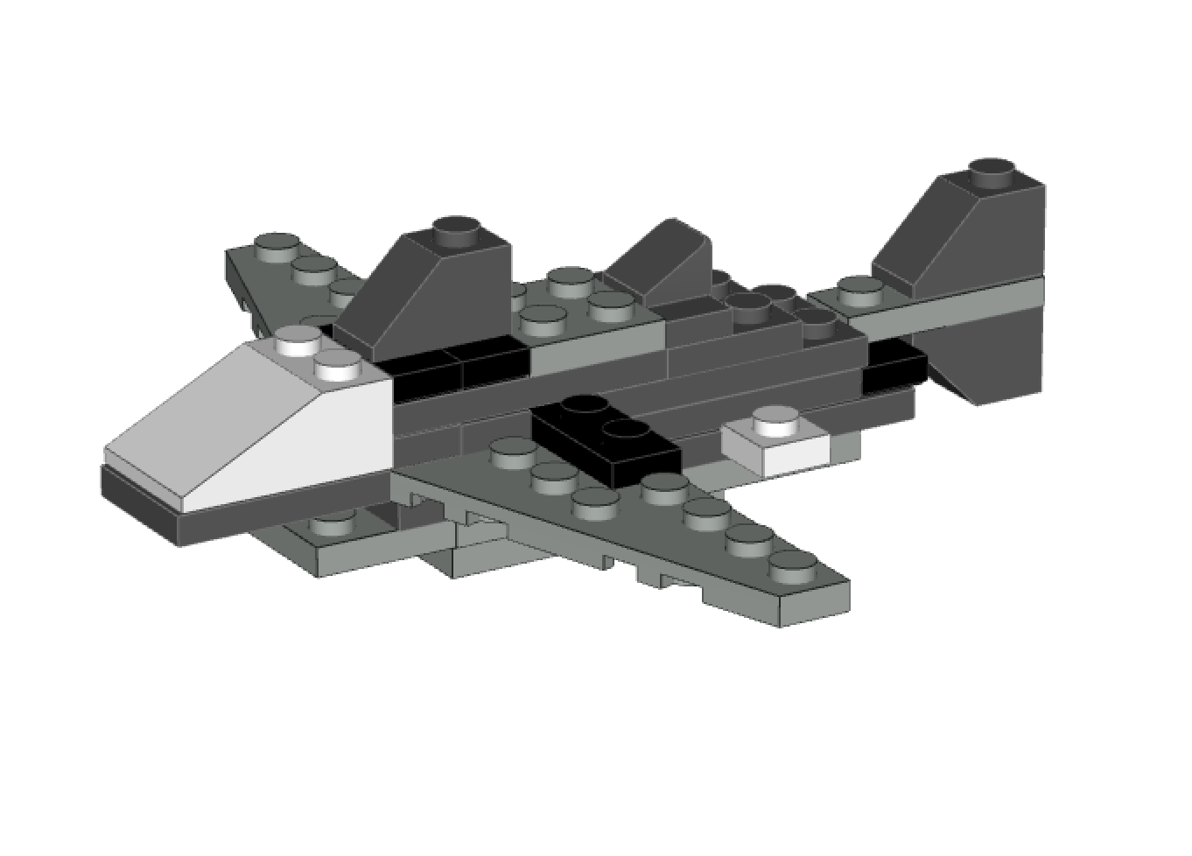

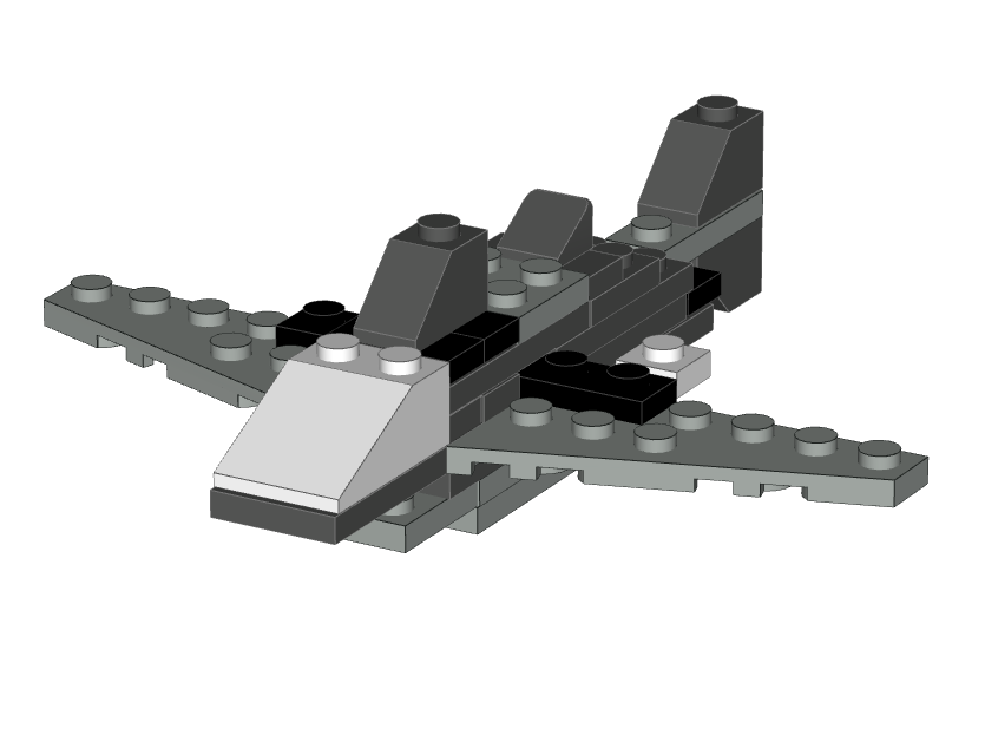

**Step 16:**

Create environment as you wish.

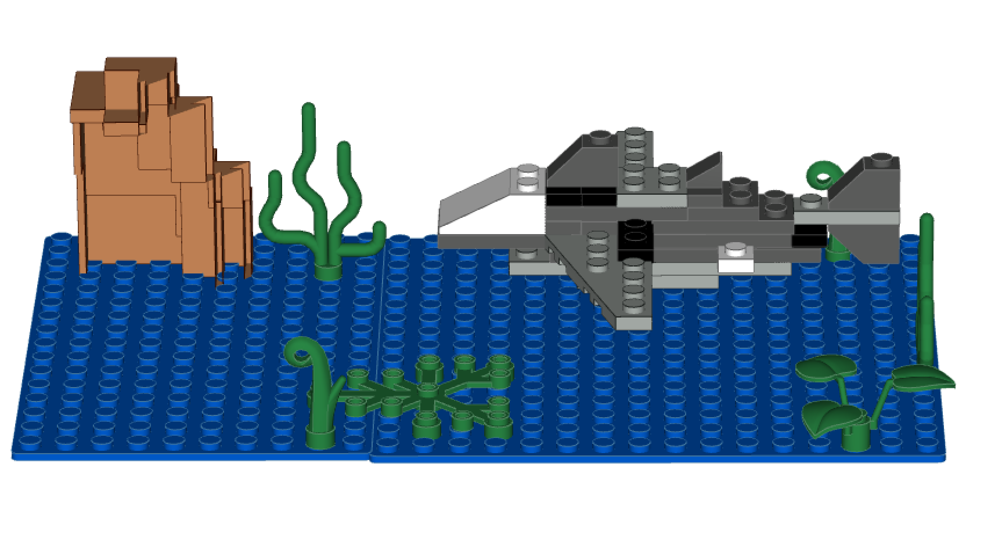

The product is complete.

We hope you enjoy and have tons of fun with this model.

Usability Test: Great White Shark Lego Model

For the assessment, we will use three criteria, 1) independent completion of tasks, 2) speed, and 3) accuracy, measured by the following benchmarks:

Benchmarks:

* Number of tasks completed without asking additional directions -- 16 tasks
* Completion time—22 minutes
* Accuracy of tasks/ number of errors—1 error

|  |  |  |  |
| --- | --- | --- | --- |
| Task: | Benchmark | User 1 | User 2 |
| Completed steps | 16 | 16 | 16 |
| Speed | 22 minutes | 25 | 23 |
| Accuracy | 1 error | 3 | 1 |

We will determine the instructions to pass the usability test if users score within 90% of the benchmarks, i.e., 13.7/15 completed steps, 25 minutes to complete, and 2 errors per user.

Reflective Memo

Technique Analysis

My partners and I broke down our project into several steps before diving into building and testing our model. Our technique analysis involved first, deciding on an appropriate and feasible model to build, and then confirming it with each other and the professor. Next, we began to delegate the workload, assigning one partner the task of building the model and another partner the task of writing the usability test and reflective memo. In this way, we used the methods of delegation to dissect the topic.

Document Genre

We chose to create our document genre in the form of a packet or booklet because we found this served our purposes best. Our model contained too many steps and was too complicated to be contained within a poster or small handout and since we used a digital drawing software to create images of our model, we thought that outing this into a video may cause too many technical challenges. In addition, according to studies I have read, many users prefer to read directions at their own pace and find videos difficult to keep up with. In this way, our document aids to usability because it is written in a format the most users prefer and find easier to use.

Instruction Methods

To illustrate our information, we used both steps, images, and text. In our instruction manual, each step is outline with either pictures of the parts it uses or a picture of what the model should look like at that point in the process. It then also explains how to complete the step. This style of presentation is very similar to many instruction manuals I have seen. It aids to usability because it gives both a visual and textual explanation of the task.

Usability Testing

The feedback from our usability tests did not play a huge role in our revisions. Both users we tested the product on scored fairly high on the usability test standards, and therefore we made minimal changes. We reviewed the images and explanations associated with the steps where errors were made, and we simplified some of the steps to cut down on how much time the process took.

Roles of Participants

Our team was made up of two people since we were not able to get in contact with our third team member. Victoria Richey primarily participated in writing the instructions and revising them. Emily Raper wrote the standards for the usability test and the reflective memo.

1. Model in introduction built by Victoria R. on modeling software Bricksmith